JAVA LAB PRACTICAL

ASSIGNMENT - 1

Done by – Noel Johnson Jacob

Roll no. – 24/SCA/BCA(AI&ML)/044

Class – BCA 2-C.

Q1 – Write a program to find the average and the sum of the N numbers using Command Line argument?

public class SumAndAverage {

public static void main(String[] args) {

int sum = 0;

int count = args.length;

for (String num : args) {

sum += Integer.parseInt(num);

}

double average = (double) sum / count;

System.out.println("Sum: " + sum);

System.out.println("Average: " + average);

}

}

OUTPUT =

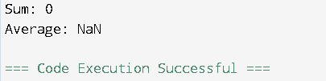

Q2 – Write a program to demonstrate type casting?

public class TypeCastingDemo {

public static void main(String[] args) {

int num = 10;

double d = num;

System.out.println("Implicit Casting (int to double): " + d);

double x = 10.5;

int y = (int) x;

System.out.println("Explicit Casting (double to int): " + y);

}

}

OUTPUT =



Q3 – Write a program to generate prime numbers between 1 to given number?

public class PrimeNumbers {

public static void main(String[] args) {

int n = 200;

System.out.println("Prime numbers between 1 and " + n + " are:");

for (int i = 2; i <= n; i++) {

if (isPrime(i)) {

System.out.print(i + " ");

}

}

}

static boolean isPrime(int num) {

if (num < 2) return false;

for (int i = 2; i \* i <= num; i++) {

if (num % i == 0) return false;

}

return true;

}

}

OUTPUT =

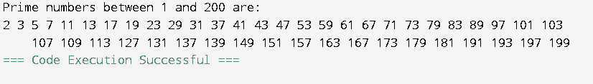

Q4 – Write a program to demonstrate Nested Switch?

import java.util.Scanner;

public class NestedSwitchDemo {

public static void main(String[] args) {

Scanner scanner = new Scanner(System.in);

System.out.println("Enter department (BCA, Btech): ");

String dept = scanner.next();

System.out.println("Enter year (1-4): ");

int year = scanner.nextInt();

switch (dept.toUpperCase()) {

case "BCA":

switch (year) {

case 1: System.out.println("Subjects: Math, Physics"); break;

case 2: System.out.println("Subjects: Data Structures, OOPs"); break;

case 3: System.out.println("Subjects: DBMS, Networks"); break;

case 4: System.out.println("Subjects: AI, Cloud Computing"); break;

default: System.out.println("Invalid year.");

}

break;

case "Btech":

switch (year) {

case 1: System.out.println("Subjects: Math, CS"); break;

case 2: System.out.println("Subjects: AI, Digital Electronics"); break;

case 3: System.out.println("Subjects: DSA, MS"); break;

case 4: System.out.println("Subjects: WT, AI&ML"); break;

default: System.out.println("Invalid year.");

}

break;

default:

System.out.println("Invalid department.");

}

scanner.close();

}

}

OUTPUT =

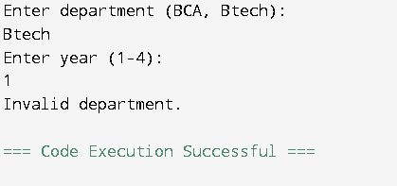

Q5 – Write a program to calculate area of circle using Radius?

import java.util.Scanner;

public class CircleArea {

public static void main(String[] args) {

Scanner scanner = new Scanner(System.in);

System.out.print("Enter radius: ");

double radius = scanner.nextDouble();

double area = Math.PI \* radius \* radius;

System.out.println("Area of the circle: " + area);

scanner.close();

}

}

OUTPUT =

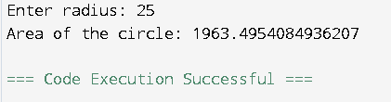

Q6 – Write a program to find GCD of two numbers?

import java.util.Scanner;

public class GCD {

public static void main(String[] args) {

Scanner scanner = new Scanner(System.in);

System.out.print("Enter first number: ");

int a = scanner.nextInt();

System.out.print("Enter second number: ");

int b = scanner.nextInt();

int gcd = findGCD(a, b);

System.out.println("GCD of " + a + " and " + b + " is: " + gcd);

scanner.close();

}

static int findGCD(int a, int b) {

while (b != 0) {

int temp = b;

b = a % b;

a = temp;

}

return a;

}

}

OUTPUT =

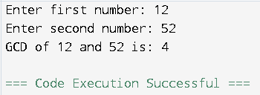

Q7 – Write a program to generate pyramid of stars using nested for loops?

public class Pyramid {

public static void main(String[] args) {

int rows = 5;

for (int i = 1; i <= rows; i++) {

for (int j = rows - i; j > 0; j--) {

System.out.print(" ");

}

for (int k = 1; k <= (2 \* i - 1); k++) {

System.out.print("\*");

}

System.out.println();

}

}

}

OUTPUT =

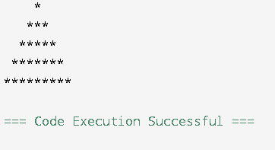

Q8 – Write a program to reversed pyramid for loops and decrement operator?

public class ReversedPyramid {

public static void main(String[] args) {

int rows = 5;

for (int i = rows; i >= 1; i--) {

for (int j = 0; j < rows - i; j++) {

System.out.print(" ");

}

for (int k = (2 \* i - 1); k > 0; k--) {

System.out.print("\*");

}

System.out.println();

}

}

}

OUTPUT:

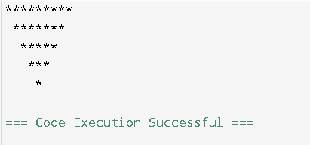

Q9 – Write a program to find the factorial of a given number using recursion?

public class FactorialRecursion {

public static int factorial(int n) {

if (n == 0 || n == 1)

return 1;

return n \* factorial(n - 1);

}

public static void main(String[] args) {

int num = 7;

System.out.println("Factorial of " + num + " is: " + factorial(num));

}

}

OUTPUT =

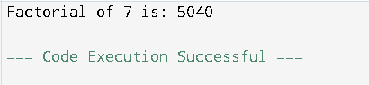

Q10 – Write a program to design using abstract methods and abstract classes?

abstract class Animal

{

public abstract void animalSound();

public void sleep()

{

System.out.println("Zzz");

}

}

class Pig extends Animal

{

public void animalSound()

{

System.out.println("The pig says: wee wee");

}

}

class Main {

public static void main(String[] args)

{

Pig myPig = new Pig();

myPig.animalSound();

myPig.sleep();

}

}

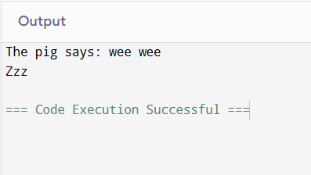

Q11 – Write a program to count the number of objects created for a class using static member function?

class ObjectCounter {

private static int count = 0;

public ObjectCounter() {

count++;

}

public static int getObjectCount() {

return count;

}

public static void main(String[] args) {

ObjectCounter obj1 = new ObjectCounter();

ObjectCounter obj2 = new ObjectCounter();

ObjectCounter obj3 = new ObjectCounter();

ObjectCounter obj4 = new ObjectCounter();

System.out.println("Number of objects created: " + ObjectCounter.getObjectCount());

}

}

OUTPUT =

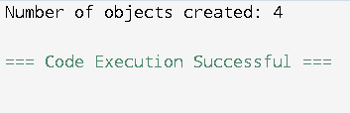

Q12 – Write a program to demonstrate the use of function overloading?

class FunctionOverloading {

public void display(int num) {

System.out.println("Integer: " + num);

}

public void display(String text) {

System.out.println("String: " + text);

}

public void display(int num1, int num2) {

System.out.println("Sum: " + (num1 + num2));

}

public static void main(String[] args) {

FunctionOverloading obj = new FunctionOverloading();

obj.display(10);

obj.display("Hello");

obj.display(5, 15);

}

}

OUTPUT =

